Created Table in HIVE to upload stocks data

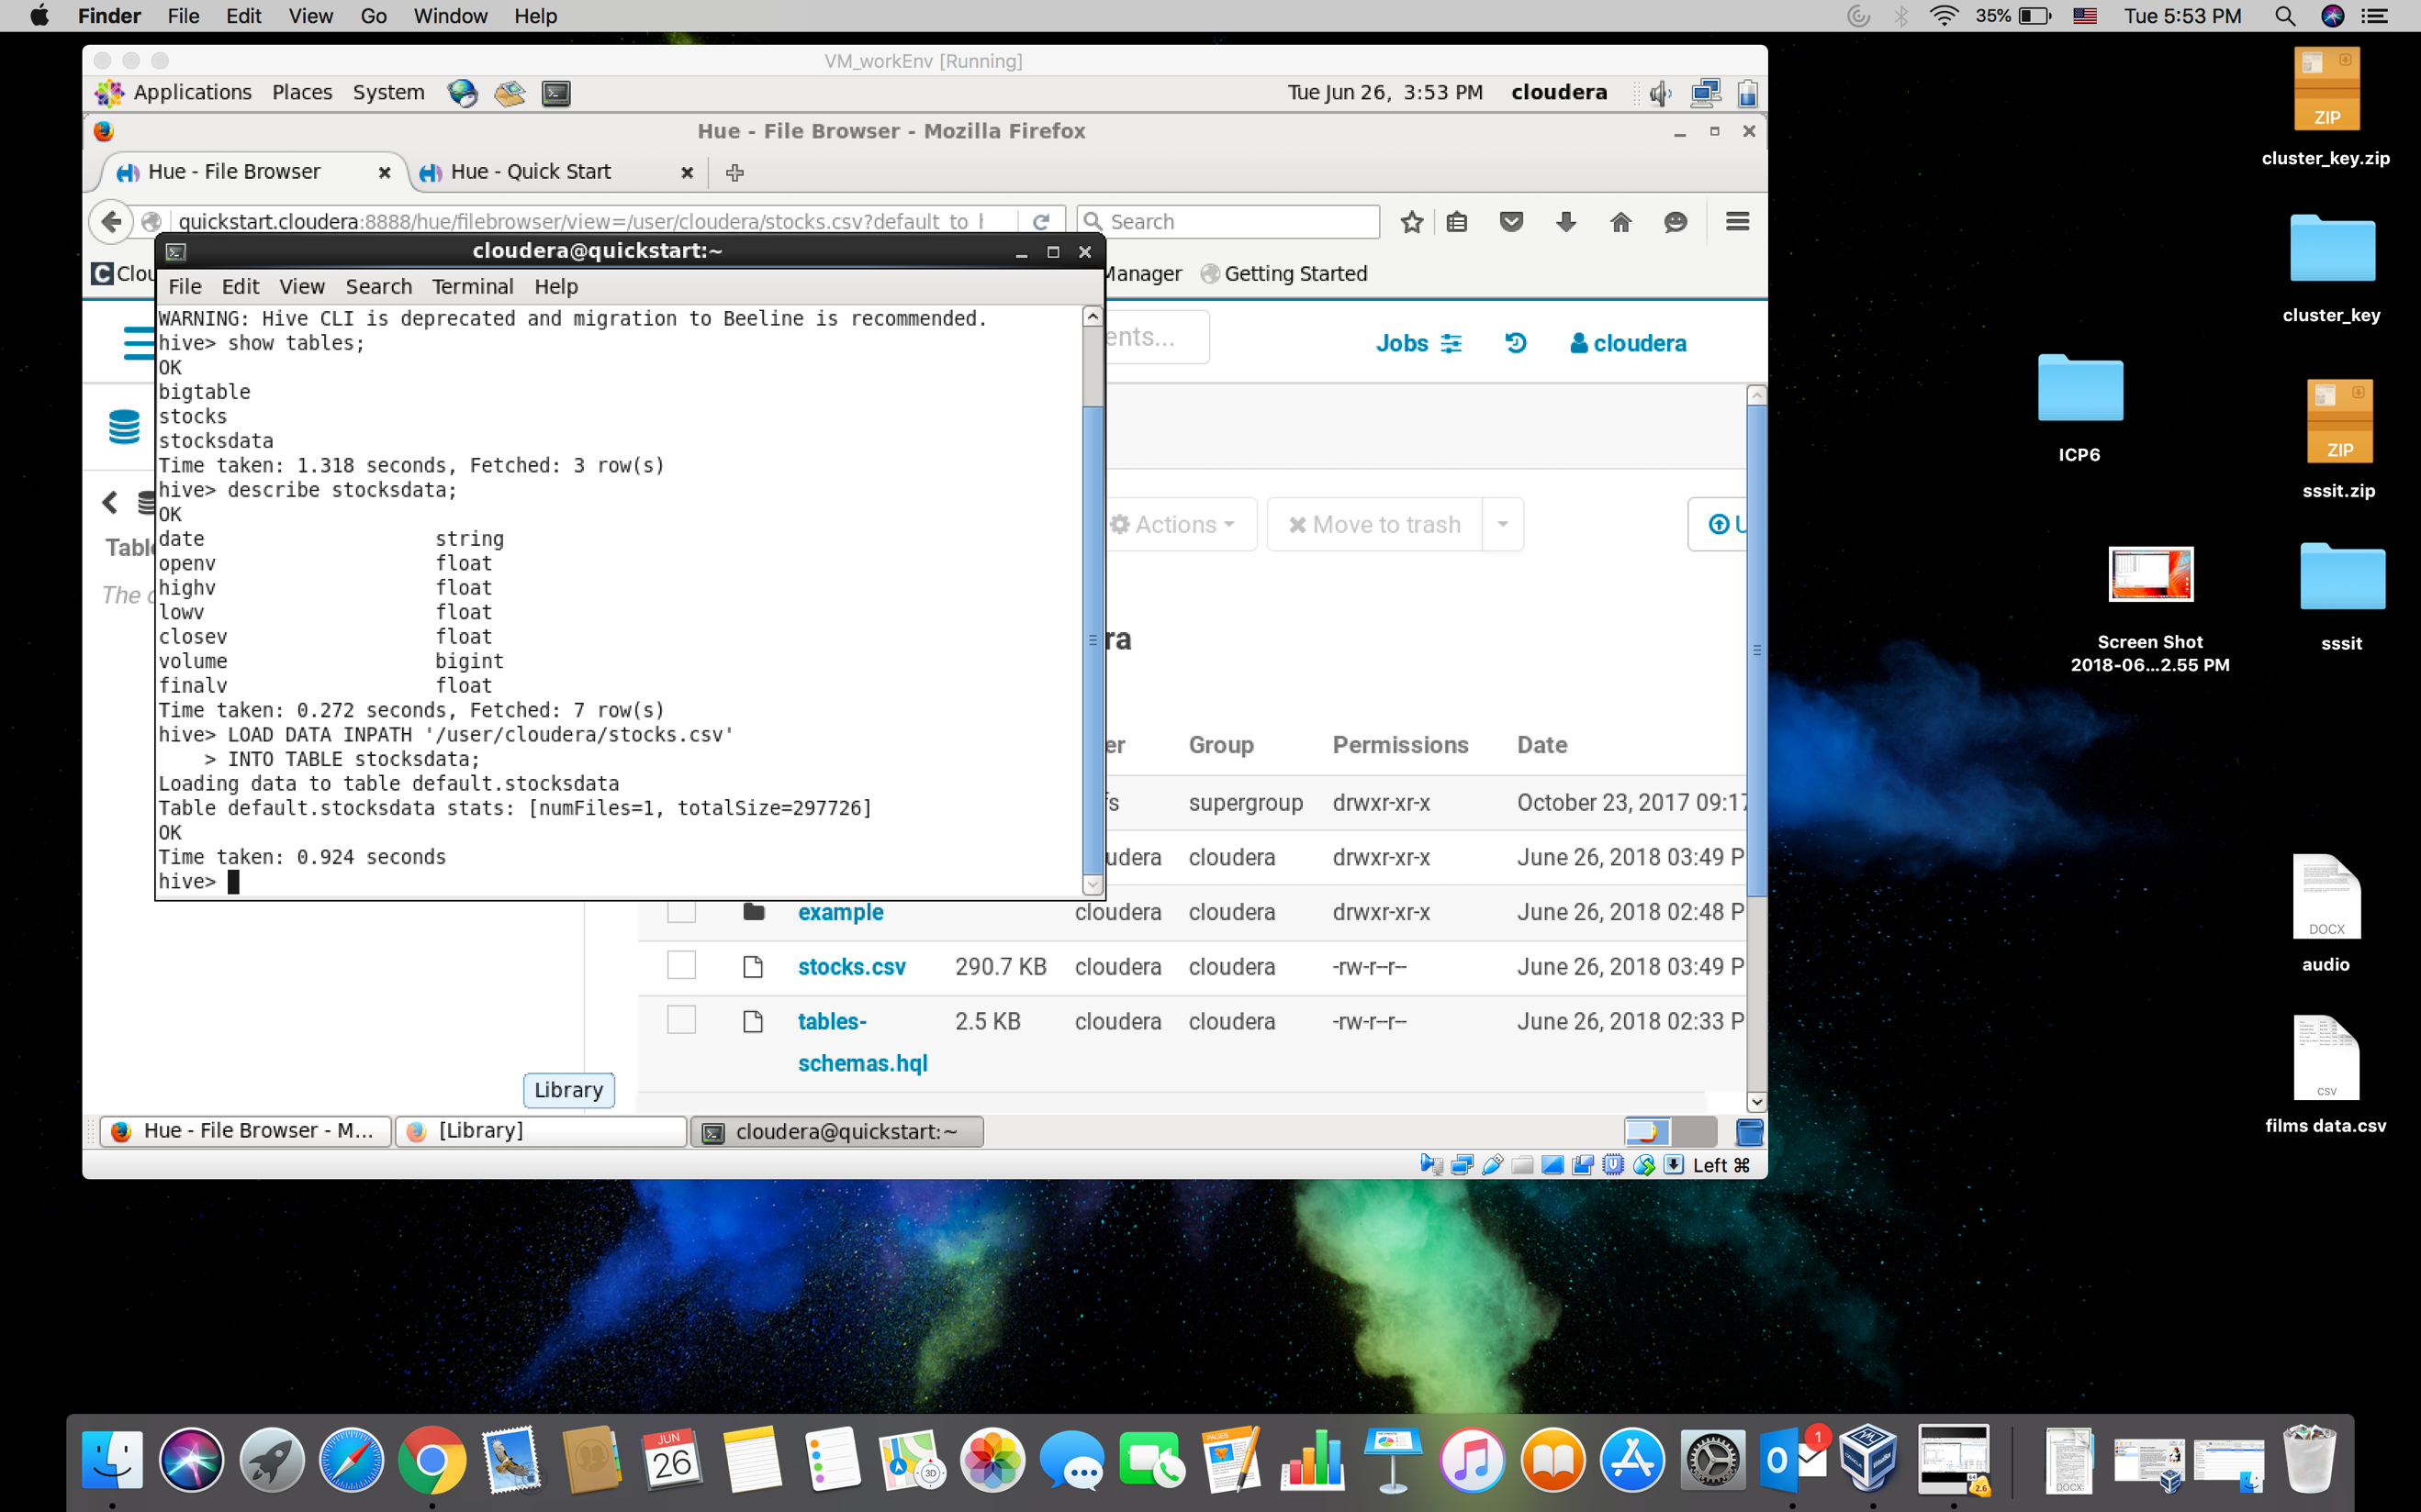

Loaded stocks data in to the hive table

Performed query to get AVG of the highv(High Value of the stock)

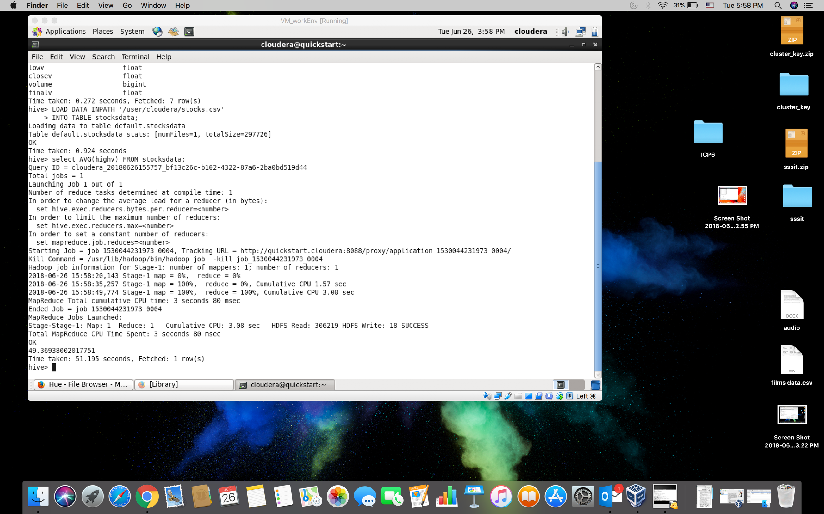

Performed query to return MIN value from the lowv column(Lowest value of the stock)

